

Math 536

EXAM REVIEW PACKAGE

FORMULAS

NOTE: Formulas will not be available on the June 2004 Math 536 exam.

Quadratic Function
General form: |  | f(x) = ax² + bx + c |  |  | where a  0
Standard form: |  | f(x) = a(x − h)²+ k |  |  | where a  0
 |  | 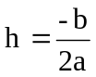 |  | and | 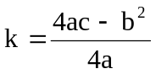
f(x) = 0 if |  | 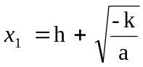 |  | and | 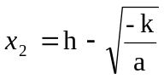
f(x) = 0 if |  | 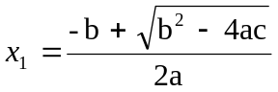 |  | and | 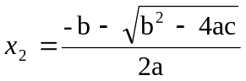

Trigonometry
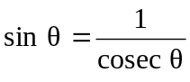 | sin²θ + cos²θ = 1
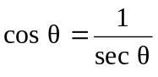 | tan²θ + 1 = sec²θ
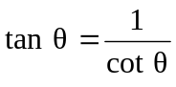 | cot²θ + 1 = cosec²θ
In a triangle, | 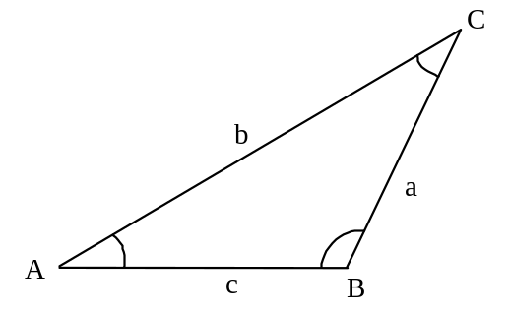
➢ 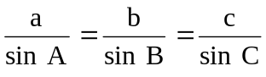
➢ 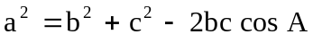

Statistics
Population | Sample
Standard score = Z score = 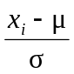 | Standard score = Z score = 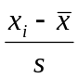
Standard Deviation = 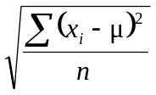 | Standard Deviation = 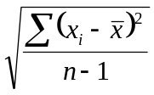

EXAMINATION #1

Part A | Questions 1 to 10  In the Answer Booklet, blacken the letter that corresponds to the answer chosen.

Given f (x) = 4x + 1 and g(x) = -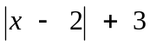.
1

What is the range of (g f)(x)?

A) | [3, ∞[ | C) | ]-∞, 14]
B) | [14, ∞[ | D) | ]-∞, 3]

A function is represented by the rule f(x) = 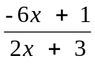.
2

Which of the following graphs represents f ⁻¹ (x)?
A) | 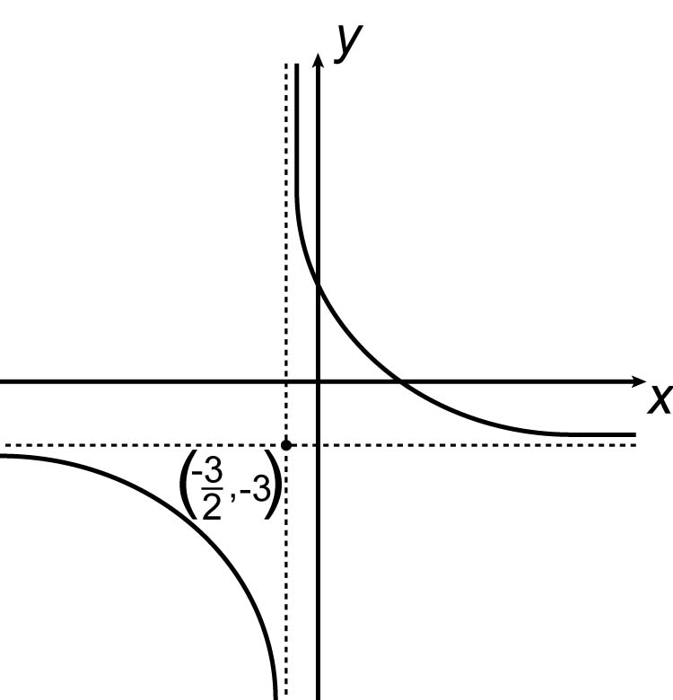 | C) | 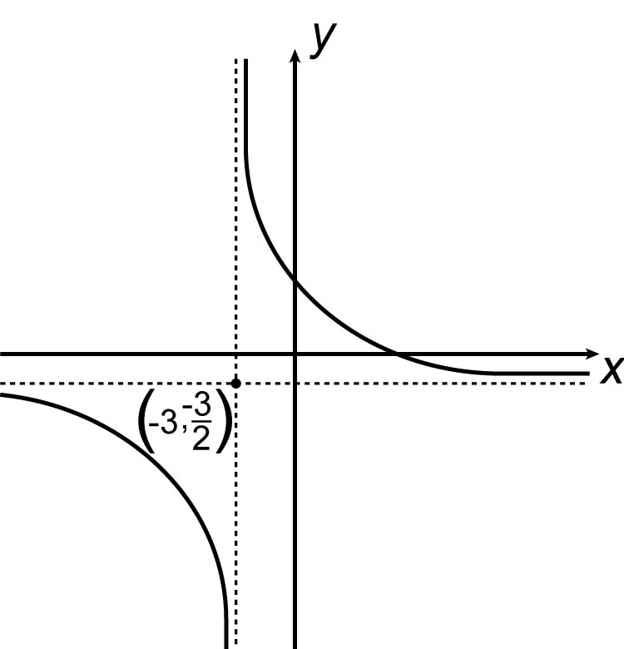
B) | 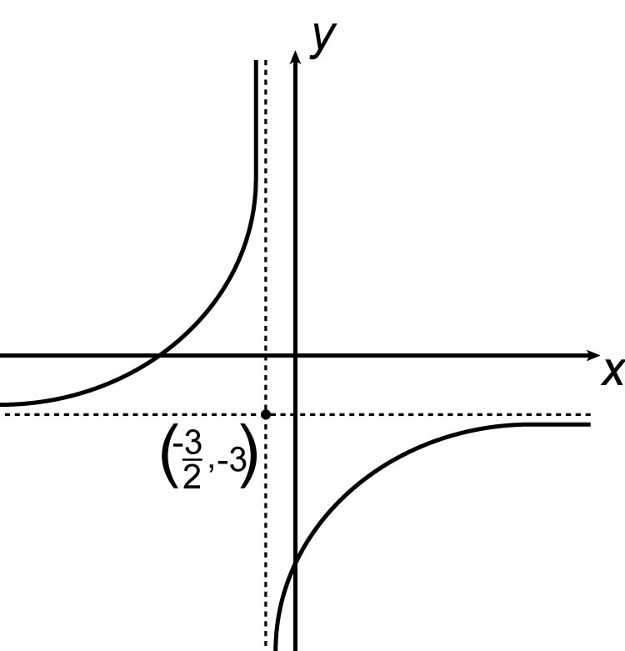 | D) | 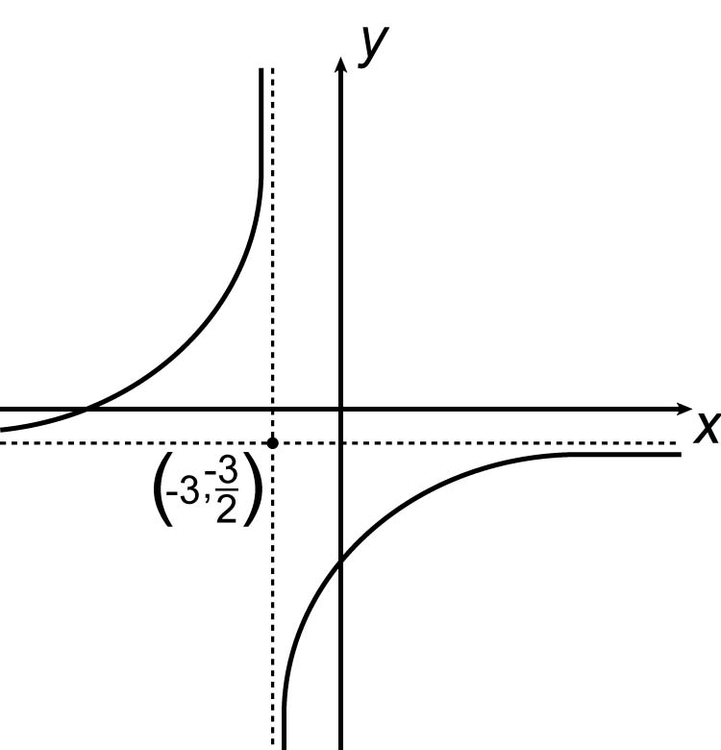

Given the standard form of the greatest integer function: f(x) = a[b(x − h)] + k and the following graph.
3

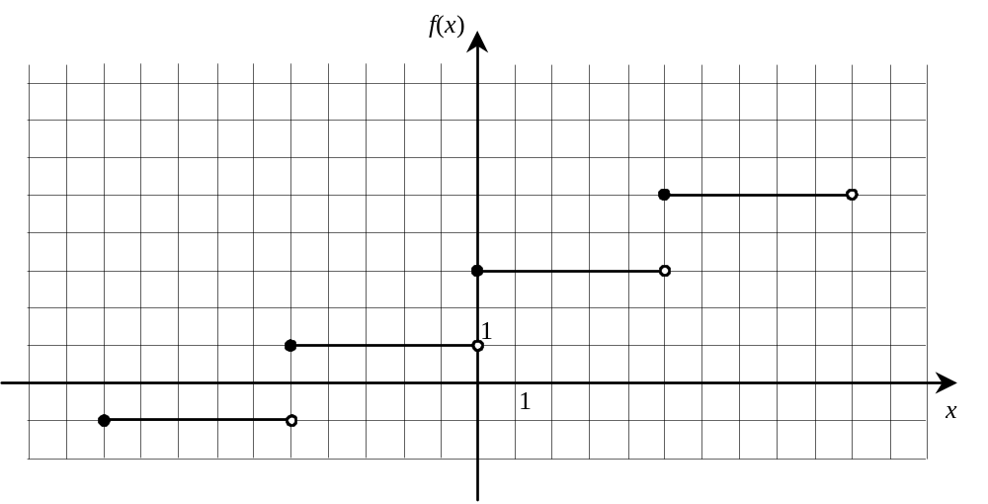

What are the respective values of parameters a and b?

A) |  and | C) | 2 and
B) | and 5 | D) | 2 and 5

In the diagram on the right, chord BD is perpendicular to diameter AC and intersects AC at point E. Triangle ABC is inscribed in the circle with centre O.  4 | 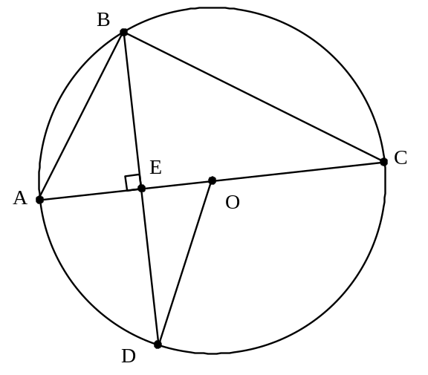
Which of the following statements is FALSE?

A) | 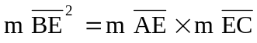 | C) | 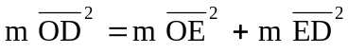
B) | 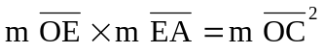 | D) | 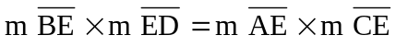

In the adjacent circle with centre O,  5  m ∠ AOB = 100°  m ∠ FDE = 55°  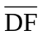 is tangent to the circle.  What is the measure of ∠ DFA? | 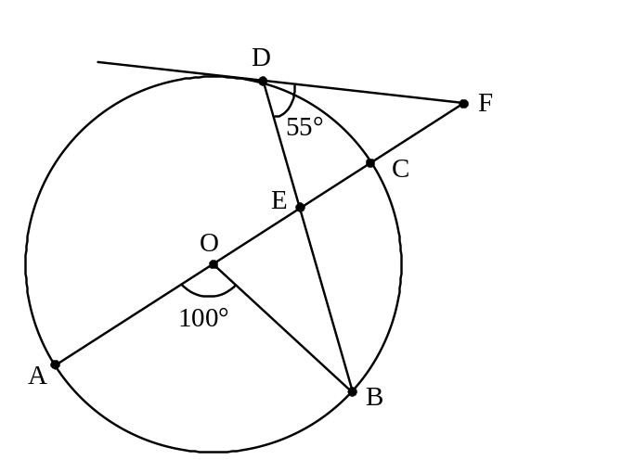

A) | 10° | C) | 35°
B) | 30° | D) | 60°

What is the simplified form of the following logarithmic expression?
6

3(log a² − log 2a) + 4 log a

A) | 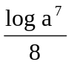 | C) | 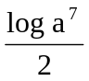
B) | 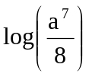 | D) | 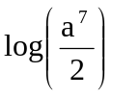

Which of the following graphs illustrates the weakest correlation between the variables?
7

A) | 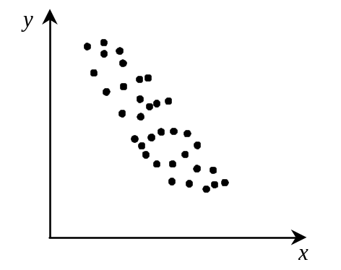 | C) | 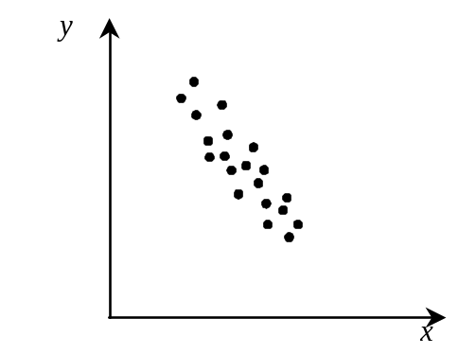
B) | 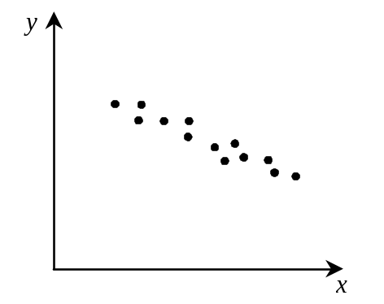 | D) | 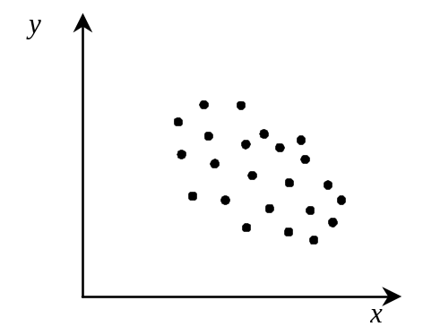

Given 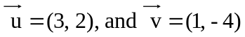
8

What are the components of the resultant of the following vector operation?

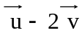

A) | (1, 10) | C) | (2, 6)
B) | (1, -6) | D) | (5, -6)

Jamie is practicing for a skateboard competition at the neighbourhood park. The ramp is in the shape of a sinusoidal function. The following graph represents the height, f(x), of the ramp, in metres, as a function of the horizontal distance, x, in metres. The maximum and minimum points of the ramp are separated by 6 metres horizontally and 3.5 metres vertically. The minimum is 0.5 metres above ground level.
9

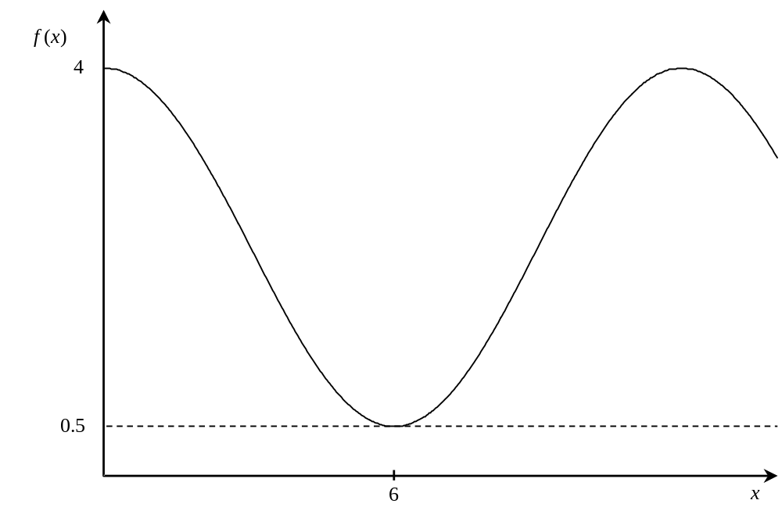

Which of the following rules represents the above situation?

A) | f(x) = 2 cos 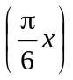 + 0.5 | C) | f(x) = 1.75 cos 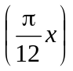 + 0.5
B) | f(x) = 2 cos + 2.25 | D) | f(x) = 1.75 cos + 2.25

Which inequality represents the shaded region bounded by the conic section shown in the graph below?
10
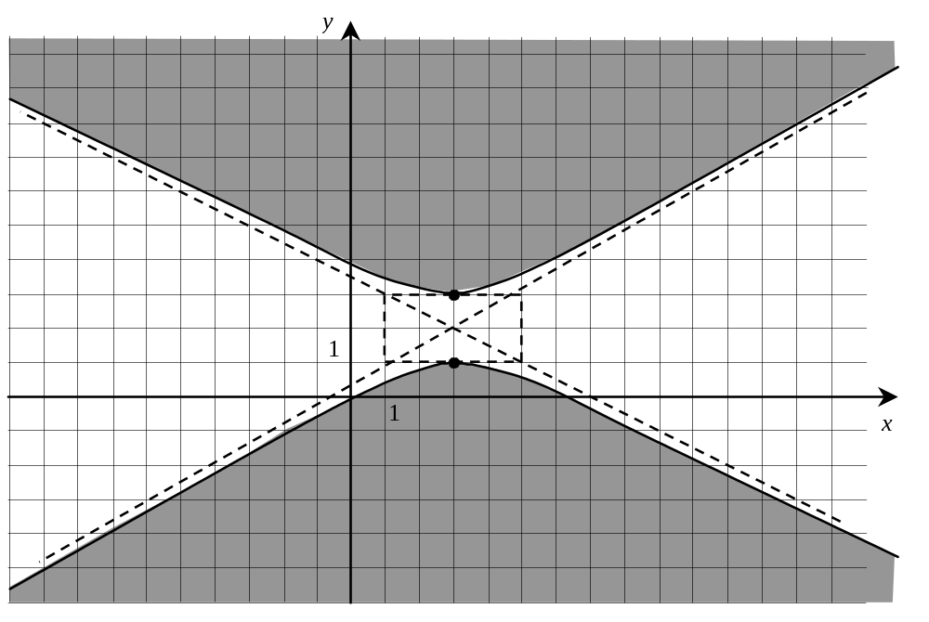

A) | 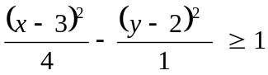 | C) | 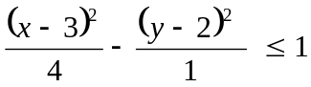
B) | 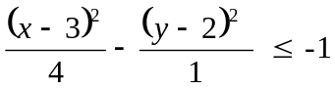 | D) | 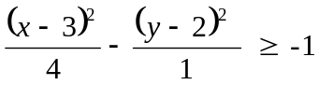

Part B | Questions 11 to 15  Write each answer in the space provided.

4 | 2 | 0

In order to raise funds for their graduation, the Secondary V students are selling T-shirts and mugs.
11

The expected profit per student is calculated according to the function:
P = 5x + 10y

where x represents the number of T-shirts sold per student
and y represents the number of mugs sold per student

These constraints are represented on the graph below.
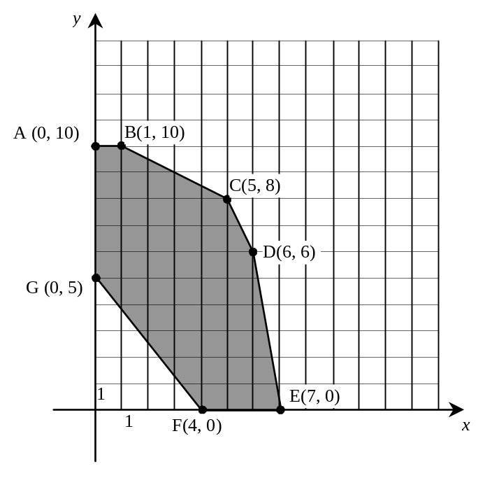
What are all the possible ordered pairs that yield a maximum profit?

The ordered pairs are: _________________________________.

4 | 0
Solve the following equation:
12

2 ^{x} = 3 ^{2x −1}

Round your answer to the nearest hundredth.

Rounded to the nearest hundredth, the value of x is _________.

4 | 0

The scalar product of vectors d and f is 138. Their respective magnitudes are 7 and 25 units.
13

What is the measure of angle θ between vectors d and f?

Round your answer to the nearest degree.

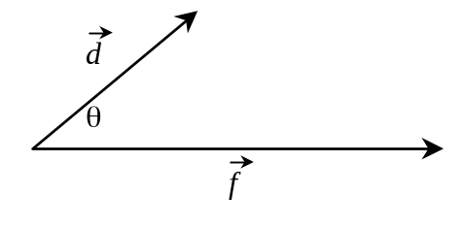

To the nearest degree, the angle measure is __________°.

4 | 2 | 0
Given the following trigonometric equation:
14

2 sin² x + 5 sin x − 3 = 0, x ∈ [0, 2π]

What are the exact values of x that satisfy this equation?

The exact values of x are __________ and __________.

4 | 0

On a given day, the market value, V(t), of Bio Tech stock shares fluctuated in relation to the time elapsed in hours, t, from the opening of the day's trading session, according to an absolute value function.
15

At the opening of trading, Bio Tech stock was worth $6. Three hours later, it reached its maximum value of $9.

How many hours had elapsed from the time the share first reached $8 until it decreased to $5?

The number of hours elapsed is __________.
Part C | Questions 16 to 25   Show all your work as well as your answer. The work shown is taken into consideration when marks are awarded.   Your written information must be legible, complete, and clearly stated in correct language so the marker understands exactly what you have done.  Even if your answer is correct, no marks will be given unless acceptable work is shown.

4 | 3 | 2 | 1 | 0

A fisherman has to separate his daily catch of shellfish into two categories before he can sell them. Lobsters are sold for $8.70 each and crabs are sold for $9.60 each.
16

On an average day, the fisherman can expect to catch a minimum of 35 crabs and a maximum of 60. By experience, there are at most twice as many lobsters as crabs in a daily catch and never has the fisherman caught more than 140 shellfish in a single day.

Using a polygon of constraints, determine the maximum revenue that this fisherman can expect to make.
Let x: number of lobsters
y: number of crabs

Graph:
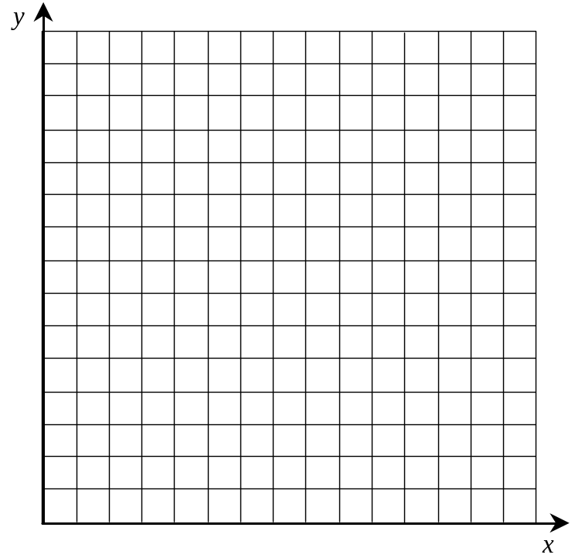

Answer: | The maximum revenue this fisherman can expect to make is __________.

4 | 3 | 2 | 1 | 0

A virus appeared in South America in the middle of the last decade. Scientists knew that the number of people infected with this virus would increase according to a specific exponential function.
17

At the beginning of 1996, authorities found 110 infected people. Five years later, the number had grown to 835. Wide-scale inoculation began once 2000 people had been infected with the virus.

In what year did these inoculations begin?

Answer: | The inoculations began in the year __________.

4 | 3 | 2 | 1 | 0
Prove the following trigonometric identity.
18

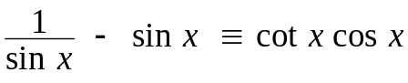

4 | 3 | 2 | 1 | 0

A dome, in the shape of a semi-ellipse, protects a tennis court, as shown below.
19

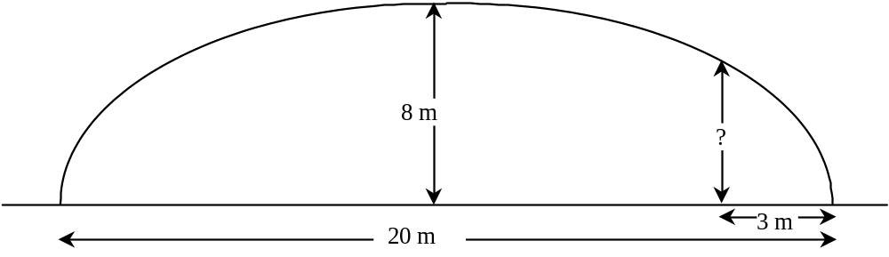

The height of the dome at the centre is 8 m and its span is 20 m. Cameras must be fixed to the roof of the dome at a horizontal distance of 3 meters from its edges.

At what height are the cameras from the ground?
(Round your answer off to the nearest hundredth.)

Answer: | The cameras are __________ m from the ground.

4 | 3 | 2 | 1 | 0

Strange geometric formations, known as crop circles, have appeared in fields around the world. The creators of the crop circle shown below would like to surround their design with a border, in the shape of an equilateral triangle.
20

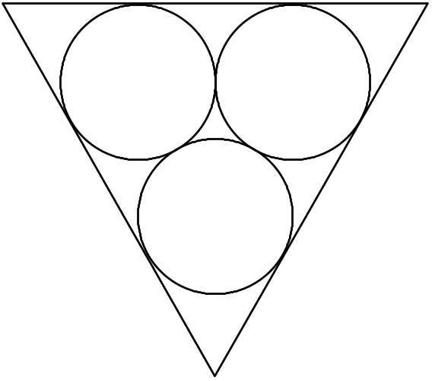
The circles that were used to make the design are congruent to the circle whose equation is:
x² + y² − 6x − 2y − 26 = 0

The circles are externally tangent to one another and tangent to the border.

What is the length of the border?
Round your answer to the nearest hundredth of a unit.

Answer: | To the nearest hundredth of a unit, the border measures __________.

4 | 3 | 2 | 1 | 0

A museum has been selected to exhibit Leonardo Da Vinci’s Mona Lisa. The floor plan of the exhibition room, measuring 30 m by 10 m is shown below.
21

To prevent visitors from touching the Mona Lisa, a fence has been installed such that every point along the fence is equidistant from the Mona Lisa (M) and wall 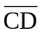 of the exhibition room.

The fence is attached to the wall on which the Mona Lisa is displayed, at points A and B.

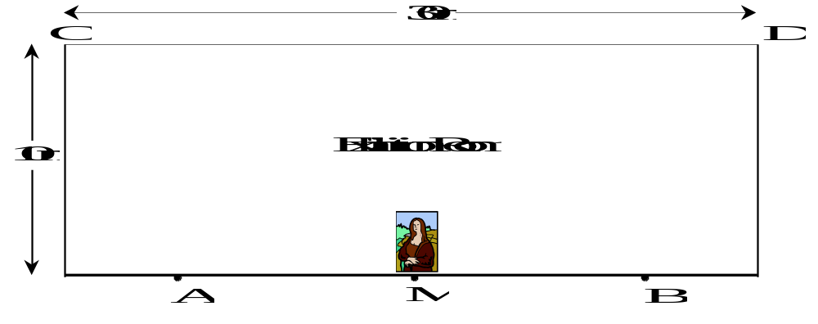

How far apart are points A and B?

Answer: | Points A and B are __________ m apart.

4 | 3 | 2 | 1 | 0

In 1996, a study was conducted on the relationship between the annual payrolls of major league baseball teams and the number of wins each recorded in a given season. The number of wins for the teams with the nine highest payrolls is listed in the table below.
22

Teams | Payroll (in millions of $) | Number of wins
New York Yankees | 61 | 92
Baltimore Orioles | 55 | 88
Atlanta Braves | 53 | 96
Cleveland Indians | 47 | 99
Chicago White Sox | 44 | 85
Cincinnati Reds | 43 | 81
Seattle Mariners | 43 | 85
Texas Rangers | 41 | 90
Colorado Rockies | 40 | 83

How many games could a team with a payroll of 30 million dollars expect to win?

Answer: | A team with a payroll of 30 million dollars can expect to win _________ games.

4 | 3 | 2 | 1 | 0

Only one Secondary V Science Fair team from Central High can advance to the provincial competition.
23

According to the results below, both Team Al and Team Optics have the identical highest score in their respective classes.

CENTRAL HIGH |  |  | CENTRAL HIGH
Chemistry classes | Scores |  | Physics classes | Scores
Team Pb | 86 |  | The Accelerators | 89
Team Al | 94 |  | The Vectors | 93
Team Ag | 81 |  | The Amps | 85
Team He | 78 |  | Team Velocity | 81
Team Xe | 83 |  | The Projectiles | 88
Team H | 79 |  | Team Gravity | 84
Team Kr | 90 |  | Team Concave | 79
Team Zn | 84 |  | The Lenses | 87
Team Hg | 93 |  | The Reflectors | 77
Team Au | 77 |  | Team Optics | 94

Which of the two teams should advance to the provincial competition?
Justify your reasoning.

Answer: | Team __________ should advance to the provincial competition  because ___________________________________________________.

4 | 3 | 2 | 1 | 0

A fence surrounding a field is represented by the circle with centre O, shown below. Points A, B, C, and D represent several fence posts. The section of the fence represented by arc AD must be replaced.
24

Given the information in the diagram, calculate the length of the fence that needs to be replaced. Round your answer to the nearest hundredth of a metre.
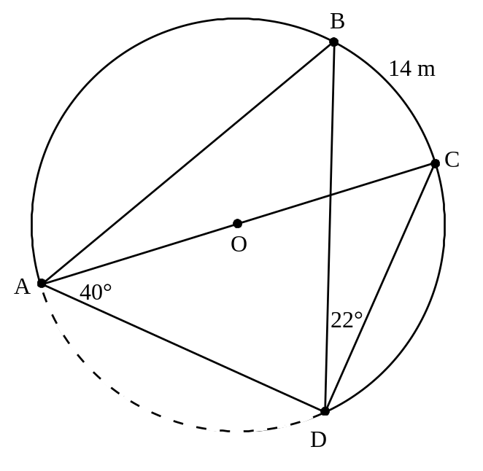

Answer: | To the nearest hundredth of a metre, the length of fence that needs to be replaced is __________ m.

4 | 3 | 2 | 1 | 0

In the adjacent circle with centre O, the radius measures 7 cm and point D is located 5 cm from the centre.  25  PAB forms a secant and 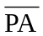 measures 8 cm. | 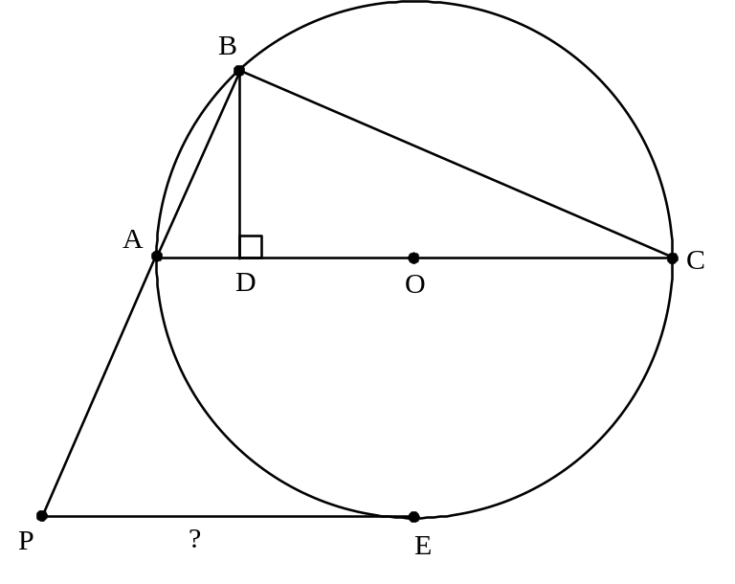

What is the measure of tangent PE?

Round your answer to the nearest tenth of a centimetre.

Answer: | To the nearest tenth of centimetre, the measure of tangent PE is __________ cm.

EXAMINATION #2

SECTION A | Questions 1 to 12.  Circle the letter that corresponds to the answer chosen.

When Aaron saw the price of roses at the neighbourhood florist shop, red roses $2.50 each, and yellow roses $1.75 each, he ordered a bouquet of red and yellow roses.
1

He insisted however that:
a) the bouquet contain at least 13 roses, and
b) the bouquet cost no more than $30.00

x = the number of red roses bought, and
y = the number of yellow roses bought.

Which of the following systems represents this situation?

A) | x ≥ 0,  y ≥ 0  x + y ≥ 13  2.50x + 1.75y ≤ 30 | C) | x ≥ 0  y ≥ 0  x + y ≤ 13  2.50x + 1.75y ≥ 30
B) | x ≥ 0  y ≥ 0  x + y ≥ 30  2.50x + 1.75y ≤ 13 | D) | x ≥ 0  y ≥ 0  x + y ≤ 30  2.50x + 1.75y ≥ 13

The basic greatest integer function, f(x) = [x], has been transformed into g(x) = a[b(x − h)] + k.
2

Which of the following statements concerning the role of the parameters is false?

A) | Parameter a affects the distance between the steps.
B) | Parameter b affects the length of the steps.
C) | Parameter h and k represent a horizontal and a vertical translation respectively.
D) | If parameter a < 0, and parameter b < 0, then function g(x) decreases over ℜ.

A hyperbola is defined by the following rule of correspondence:
3

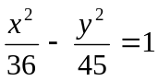

What is the distance between the foci of this hyperbola?

A) | 6 | C) | 12
B) | 9 | D) | 18

Given f(x) = 2(5^{x + 1}), then which of the following represents f ⁻¹(x)?
4

A) | 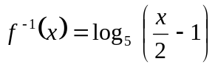 | C) | 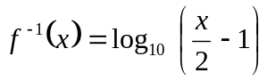
B) | 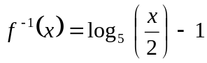 | D) | 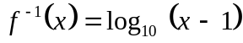

A certain sinusoidal function is determined by the rule:
5

y = -3 sin 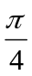 (x − 2) − 1

Which of the following statements is true?

A) | The amplitude is 3 and the period is .
B) | The amplitude is –3 and the vertical translation is –4.
C) | The function has a maximum of 2 and a period of 8.
D) | The function has a maximum of 2 and a period of 4.

Two lampposts are located 40 m apart as illustrated in the diagram below. A walkway is to be constructed around the lampposts such that the sum of the distances of any point on the walkway to the two lampposts is always 70 m.
6



Which one of the following equations could represent this situation?

A) | 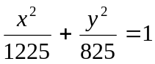 | C) | 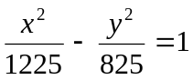
B) | 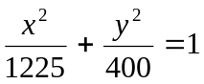 | D) | 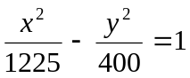

Given and , two vectors illustrated below.
7

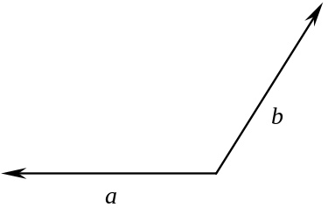

Which one of the following diagrams illustrates the relation between and and , the resultant vector?

A) | 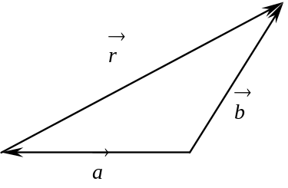 | C) | 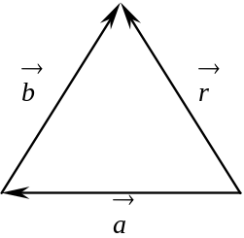
B) | 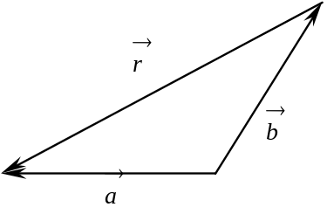 | D) | 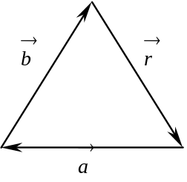

An airplane flying East at 150 km/h encounters a 50 km/h wind blowing in a 30° East of North direction.
8

What will be the airplane's resultant velocity?

A) | 180 km/h [E 14° N] | C) | 200 km/h [N 30° E]
B) | 195 km/h [E 7° N] | D) | 132 km/h [E 19° S]

Secants AE and CE are drawn to circle with centre O intersecting it at points A, B, C and D as illustrated. Chord AF intersects secant CE at T.
9

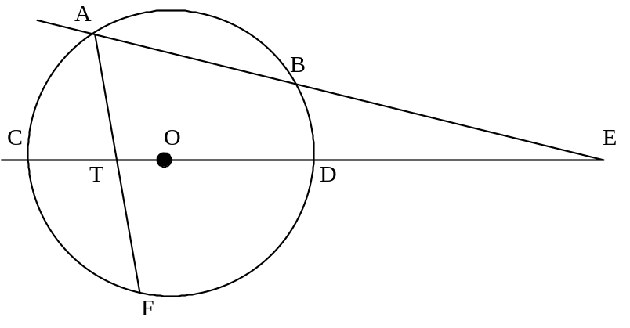

Which one of the following statements is true?

A) | 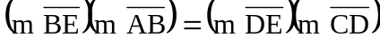 | C) | 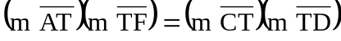
B) | 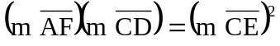 | D) | 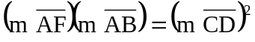

Quadrilateral ABCD is inscribed in circle O, as illustrated. Segment BE is tangent to the circle at B. The following measurements are given:
10

m ∠BCD = 130°  m ∠ADC = 90°  m ∠CBE = 20°  m  = 120°  m ∠FAD = 10°  What is the measure of angle AEB? | 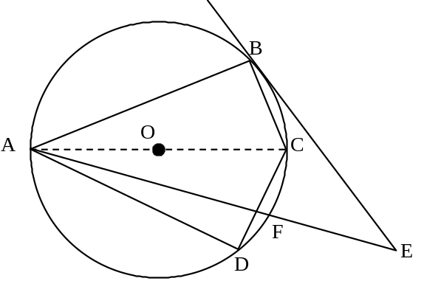

A) | 60° | C) | 40°
B) | 50° | D) | 30°
Physics students conducted an experiment to determine the relationship between the velocity (v) of a free-falling object and the time (t) elapsed since its release.
11

The scatter plot of the experimental data obtained is illustrated below.

Which one of the following values is the best approximation of the correlation coefficient between these two variables?

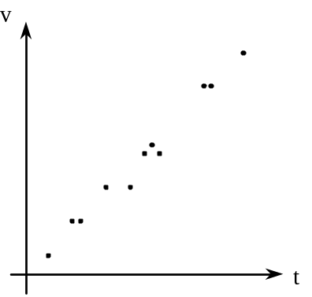
A) | 0.9 | C) | 0.1
B) | -0.9 | D) | -0.1

Here are the Math 536 marks for Melanie's class in the Christmas examination session. Melanie's mark is framed.
12

52 | 66 | 99 | 60 | 89
97 | 61 | 68 | 50 | 96
55 | 50 | 77 | 92 | 98
63 | 63 | 56 | 52 | 86
50 | 71 | 65 | 98 | 71

The CEGEPs that Melanie is considering require different minimum standard scores (Z-scores) for entrance into the program that interests her.

The table below illustrates the minimum score that a student is required to have to be admitted.

CEGEP | Minimum Z-score  Required
Dawson | 0.81
John-Abbott | 0.83
Vanier | 0.85
Mariannopolis | 0.87

Which of the CEGEPs would admit Melanie based on her standard (Z-score)?

A) | Dawson only
B) | Dawson and John-Abbott only
C) | Dawson, John-Abbott and Vanier only
D) | All four CEGEPs

SECTION B | Questions 13 to 25.  Show your work and your answer.  Both your work and your answer are taken into account when marks are allotted. No marks are given if acceptable work is not shown, regardless of the answer.
 |  |  | 4 | 3 | 2 | 1 | 0

Wheeler is a producer of mountain bikes and road bikes. Because of its small size, it can build no more than 80 bikes each week. To meet certain conditions in its workshop, it must build at least 45 mountain bikes, and at least 10 road bikes weekly. To meet consumer demand, it must manufacture at least 3 times as many mountain bikes as road bikes.
13

The following is the system of constraints for Wheeler's weekly bike production:

x = the number of road bikes produced weekly
y = the number of mountain bikes produced weekly

x ≥ 0
y ≥ 0
x ≥ 10
y ≥ 45
x + y ≤ 80
y ≥ 3x

For each road bike and mountain bike produced, Wheeler earns a profit of $250 and $175, respectively.

What is the maximum weekly profit that can be earned?

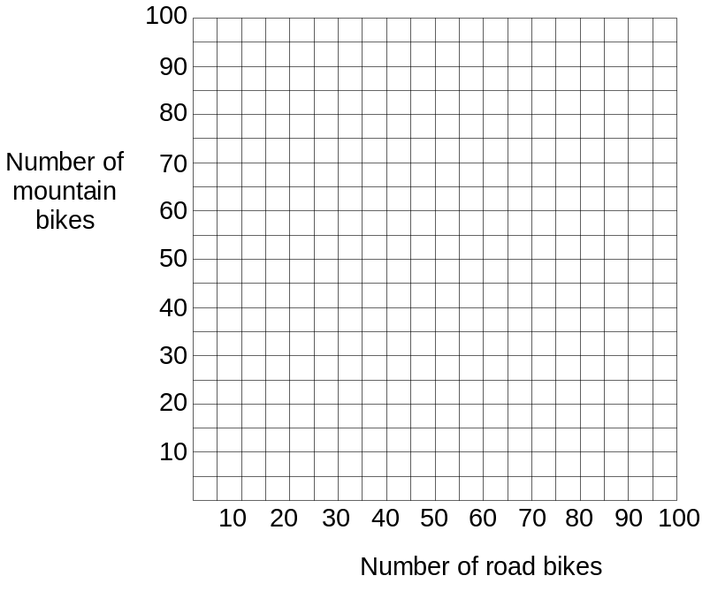
Answer: | The maximum weekly profit is $_______________.
 |  |  | 4 | 3 | 2 | 1 | 0

During one month this spring the value of a share in a travel company behaved according to an absolute value function.
14
Its initial value was $4 below its average price.
On Day 2 and Day 8 it was exactly the same as its average price.
This situation can be represented by the graph below.

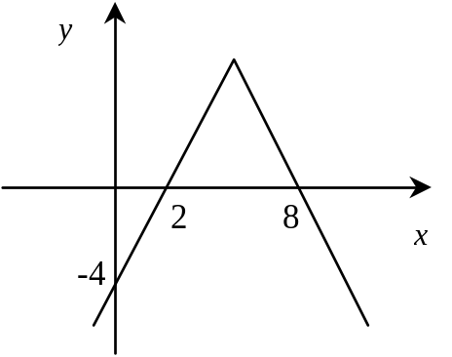

What is the rule of correspondence that represents this situation?

Answer: | The rule of correspondence is y = ____________________.

 | 4 | 3 | 2 | 1 | 0

What are the exact values of A that satisfy the following trigonometric equation?
15

sin A cot A + 2 cos² A = 1, A ∈ [0, 2π]

Answer: | The solution is A = __________________.

 | 4 | 3 | 2 | 1 | 0

Terry wants to create a protected rectangular garden next to the house by erecting a fence on three sides of the plot as illustrated in the diagram below.
16

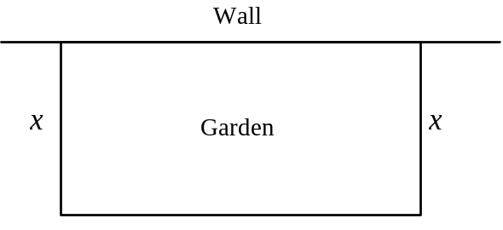

x = length of the congruent sides of the fence

Terry has 25 m of fencing and would like to enclose an area of at least 50 m².

What is the smallest value of dimension x that represents this situation?

Answer: | The smallest value of dimension x is __________________ m.

 | 4 | 3 | 2 | 1 | 0

Each morning, the traffic on a certain highway increases, reaches a peak, and then decreases again.
17

This situation is represented mathematically by the function:

V(t) = -25 | t − 8 | + 65

V(t) = the number of vehicles passing per minute
t = the time, in hours, since midnight

To ensure a smooth and safe flow of traffic, a police officer has been assigned to monitor this section of highway when the volume of traffic is at least 35 vehicles per minute.

For how many hours should the police officer be on duty to ensure the safe flow of traffic?

Answer: | The police officer should be on duty for __________________ hours.

 | 4 | 3 | 2 | 1 | 0
What is (are) the solution (s) of the following equation?
18

log₅ (x − 1) + log₅ (x + 3) − 1 = 0

Answer: | The solution (s) of the equation is (are) ____________________.

 | 4 | 3 | 2 | 1 | 0

Two circles, centred at points C and D, are tangent to a straight line segment, at points A and B, respectively, as illustrated in the diagram below.
19

These circles are defined by the rules:

Circle C: (x + 3)² + (y − 2)² = 16
Circle D: (x − 5)² + (y + 2)² = 4

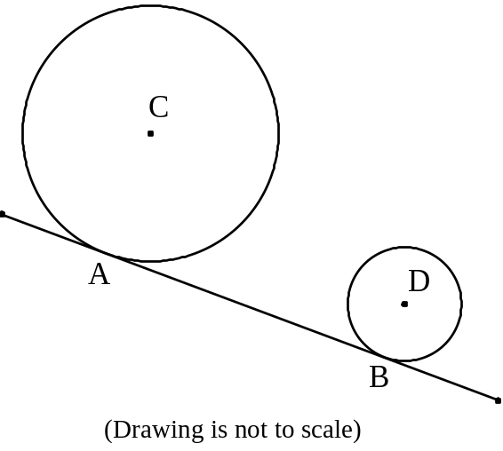

What is the distance, in units, between tangent points A and B?

Answer to the nearest hundredth unit.

Answer: | The distance from point A to point B is approximately __________ units.

 | 4 | 3 | 2 | 1 | 0

A circle with centre O and radius 5 units is drawn tangent to sides AB and AC of equilateral triangle ABC, as illustrated in the diagram below.
20

AD, the bisector of angle BAC, passes through centre O of the circle.  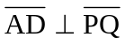  Chord PQ measures 8 units. | 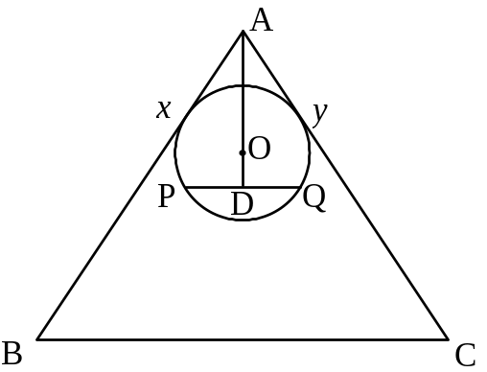

What is the measure of ?

Justify your statements.

Answer: | The measure of 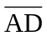 is __________ units.

 | 4 | 3 | 2 | 1 | 0

On her 21st birthday, Marie received a lump sum of money. At that time, she decided to invest it at a fixed annual interest rate, compounded yearly, until her 30th birthday.
21

On her 25th birthday, her investment had grown exponentially to $11 360.08. On her 30th birthday, it had further grown to $16 691.69.

This situation is represented in the graph below.

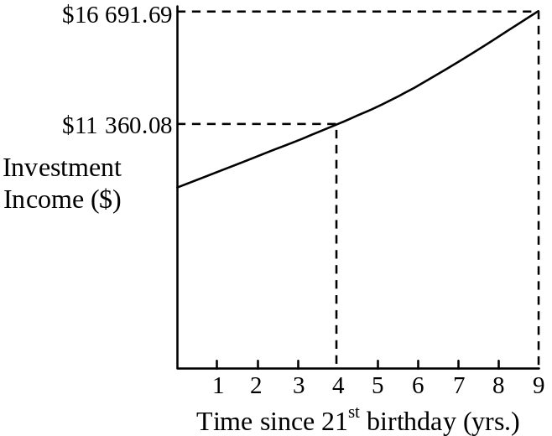

What was the fixed annual interest rate over this nine-year period?

Answer to the nearest tenth of a percent.

Answer: | The annual fixed interest rate is approximately __________ %.

 | 4 | 3 | 2 | 1 | 0

A student in Math 536 was designing a Halloween mask. He decided to draw an ellipse with equation 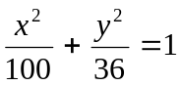 as illustrated below.
22

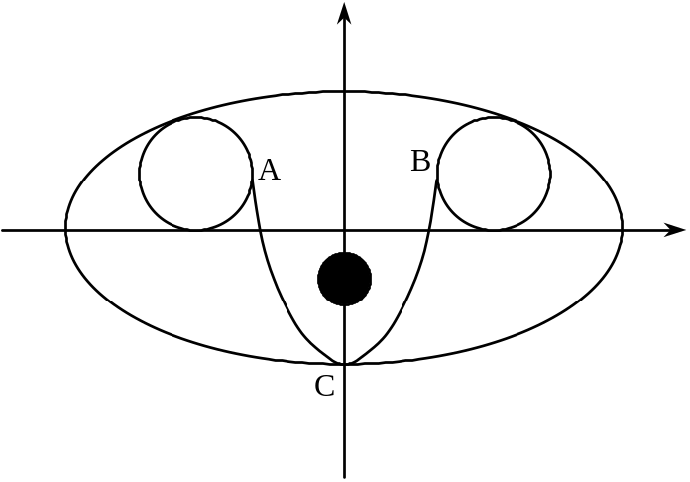

He then drew two eyes, represented by circles with radii of 2 units, tangent to the major axis of the ellipse. The centres of the circles are located directly above the foci of the ellipse.

Next he drew a parabola which intersects two circles at points A and B respectively. Points A and B are on a line connecting the centres of the circles. The parabola is also tangent to a vertex of the ellipse at point C.

The final step was to draw a nose represented by the dark circle in the diagram. The centre of the circle is the focus of the parabola.

What are the coordinates of the centre of the dark circle?

Answer: | The coordinates of the centre of the dark circle are _______________.
 |  |  | 4 | 3 | 2 | 1 | 0

A two-stage model rocket is launched from ground level. Its 1st stage (engine) powers the rocket vertically, according to the rule H(t) = 200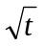,
23

where H(t) is height, in metres,
and t is time, in seconds, after launch.

At 25 seconds, the exhausted 1st stage is ejected, and the 2nd stage fires. The height of the rocket after the first 25 seconds can be expressed according to a new square root function of the form 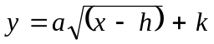.

50 seconds after the initial launch the rocket reaches a height of 2500 m.

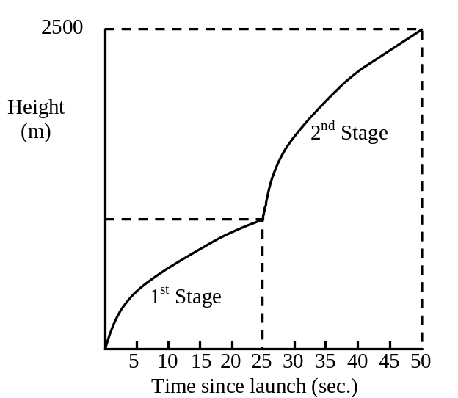

What is the height of the rocket 11 seconds after the firing of the 2nd stage?

Answer to the nearest metre.

Answer: | To the nearest metre, the height of the rocket 11 seconds after the firing of the 2nd stage was __________ m.
 |  |  | 4 | 3 | 2 | 1 | 0

In the 1984 Olympic games, the 10 best jumps, measured in centimetres in the Men's and Women's High Jump, were as follows:
24

Men's High Jump (cm) | Women's High Jump (cm)
239 | 207
237 | 205
237 | 202
236 | 200
234 | 200
234 | 199
233 | 198
233 | 198
233 | 197
233 | 197

A debate ensued between the male athlete who jumped the highest and the female athlete who jumped the highest.

The male athlete with the highest jump said to the female winner of the event, "I am the better athlete because I jumped higher than you did."

She replied, "You may have jumped higher but I can prove to you that I am the better athlete."

Using your knowledge of statistics, how would you prove that she was right?

Answer: | The female athlete was correct because:  _________________________________________________________  _________________________________________________________  _________________________________________________________
 |  |  | 4 | 3 | 2 | 1 | 0

A team of landscape architects is hired to design the layout of two garden areas, one circular and the other elliptical in shape, as in the diagram below.
25

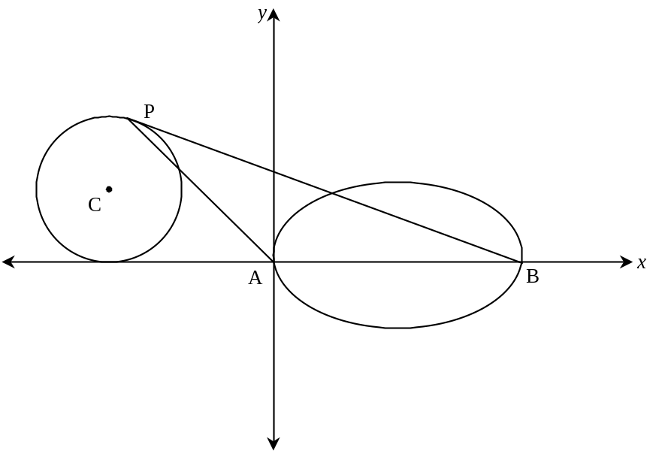
The equation of the circle is (x + 5)² + (y − 3)² = 9.

The equation of the ellipse is 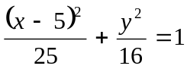.

The architects label the vertices of the ellipse A and B.

Circle C is tangent to the x axis at Q, and P is a point on the circle such that PB is a tangent line to the circle.

They wish to construct three irrigation pipes connecting P to A to B, and back to P, forming triangle PAB.

What is the total length of the irrigation pipes forming triangle PAB? Answer to the nearest tenth.

Answer: | To the nearest tenth, the total length of the irrigation pipes is ________ m.

EXAMINATION #3

SECTION A | This part of the exam comprises questions 1 to 13.  Circle the letter which corresponds to your answer.

A customer at a framing shop wanted to buy a rectangular frame for a painting. These were his requirements:
1

The length of the frame is at least 3 times the width.
The perimeter of the frame must be less than or equal to 200 cm.
The width of the frame is at most 30 cm.

Which system of constraints represents this situation?

Let: x: width y: length

A) | x ≥ 0  y ≥ 0  x + y ≥ 200  y ≤ 3x  x ≤ 30 | C) | x ≥ 0  y ≥ 0  2x + 2y ≤ 200  y ≥ 3x  x ≤ 30
B) | x ≥ 0  y ≥ 0  x + y ≤ 200  y ≥ 3x  x ≥ 30 | D) | x ≥ 0  y ≥ 0  2x + 2y ≥ 200  y ≥ 3x  x ≥ 30

Which of the following is the inverse of: f(x) = 3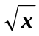 + 8, x ≥ 0?
2
A) | f ⁻¹(x) = 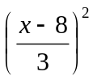, x ≥ 8 | C) | f ⁻¹(x) = 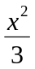− 8, x ≥ 8
B) | f ⁻¹(x) = 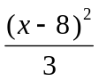, x ≥ 8 | D) | f ⁻¹(x) = 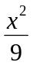− 8, x ≥ 8

The graph of a function is shown below.
3

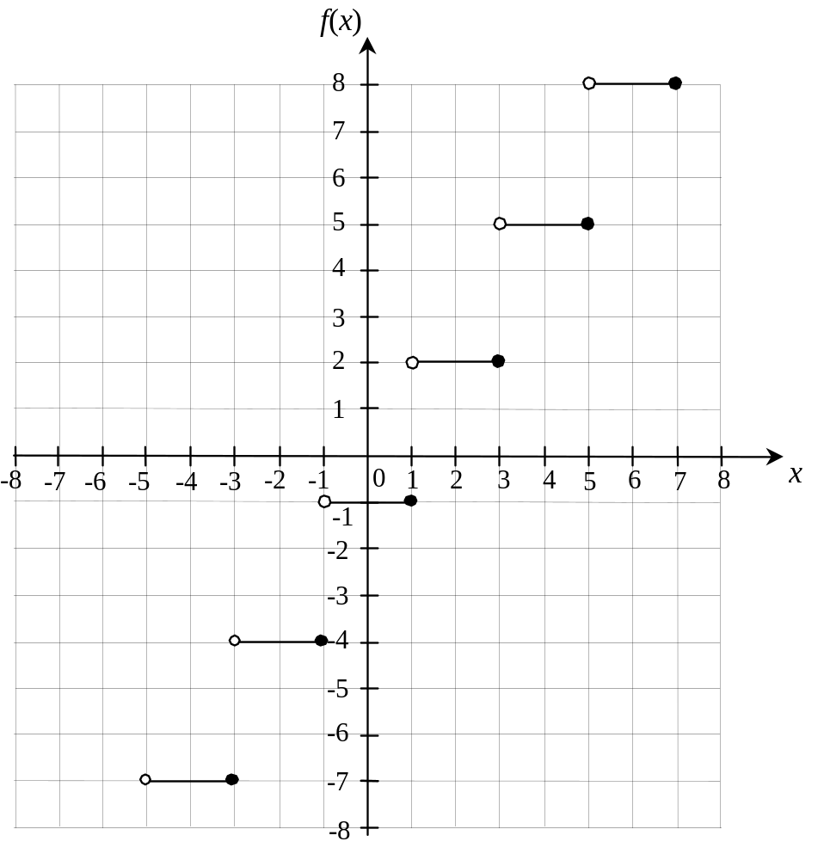

Which of the following equations describes the function shown in the graph?

A) | f(x) = -3[2(x − 1)] − 1 | C) | f(x) = -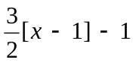
B) | f(x) = -3[-2(x − 1)] − 1 | D) | f(x) = -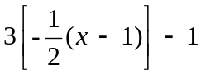

Given the function f(x) = 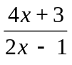.
4

What are the coordinates of the point of intersection of its vertical and horizontal asymptotes?

A) | 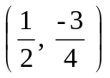 | C) | 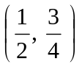
B) | 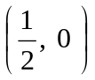 | D) | 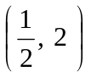

If f(x) = 3^{(x − 9)} and g(x) = log₉ x, what is (g f)(x)?
5

A) | (g f)(x) = 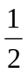(x − 9) | C) | (g f)(x) = 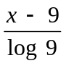
B) | (g f)(x) = (x − 9) | D) | (g f)(x) = 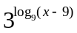

Given log₂ 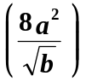, where (log₂ a = x) and (log₂ b = y), which of the
6

following expressions is equivalent to it?
A) | 3x² − 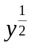 | C) | 2x 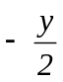 + 3
B) | 3x²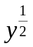 | D) | x²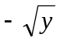 + 3

Which of the following is true for 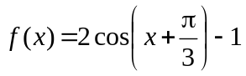?
7

A) | It increases on 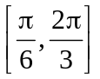 and decreases on 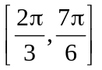
B) | It decreases on 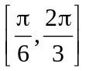 and increases on
C) | It increases on 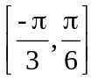 and decreases on 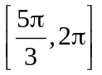
D) | It decreases on and increases on

A graphic artist is using a computer to create a cartoon figure. The figure is shown in the Cartesian plane below.
8

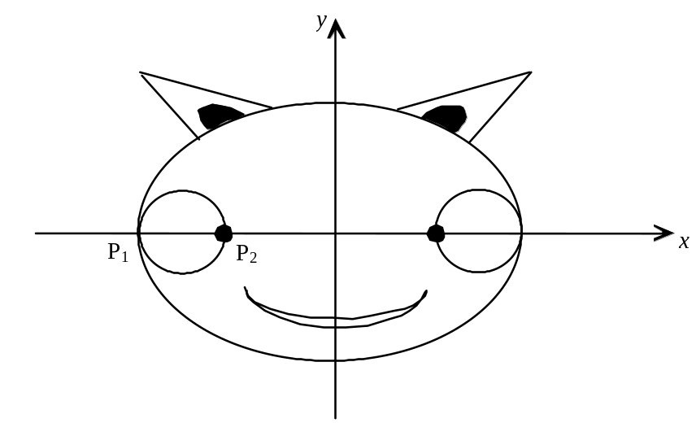

The two eyes of the figure are circles and the equation of the circle with diameter 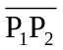 is
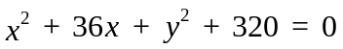

The face of the figure is an ellipse. The point P₁ corresponds to a vertex of the ellipse and the point P₂ corresponds to a focus.

Which of the following is the equation of the ellipse?

A) | 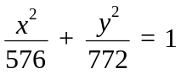 | C) | 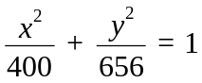
B) | 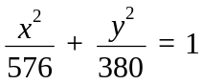 | D) | 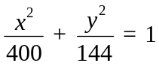

The logo of a graphics company is shown in the diagram on the right. The logo is a rectangle divided by a parabola.  9  In designing the logo, the company used the equation  y ² = 50x  to draw the parabola.  The rectangle is labelled ABCD. Side AD is on the directrix of the parabola and its focus is on side BC. | 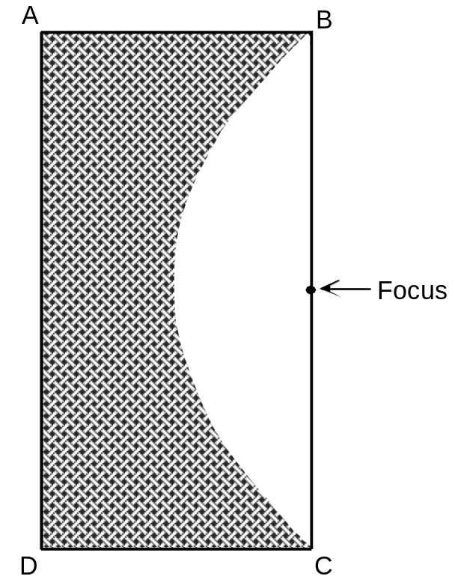  Directrix
To the nearest unit, what is the length of side BC of the rectangle?

A) | 25 units | C) | 71 units
B) | 50 units | D) | 100 units

Given that u and v are vectors, which of the following is NOT a vector?
10

A) | 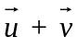 | C) | 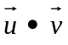
B) | 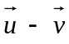 | D) | 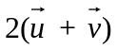

In the scalene triangle XYZ on the right, segment YW bisects angle XYZ.  11  Which of the following statements is TRUE? | 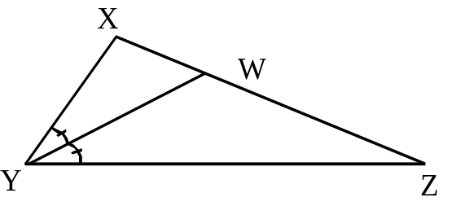

A) | 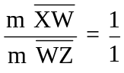 | C) | 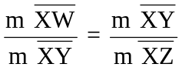
B) | 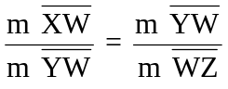 | D) | 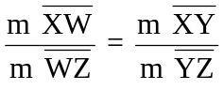

In the figure below, the central angle BOD measures 10° and angle OBE measures 30°.
12
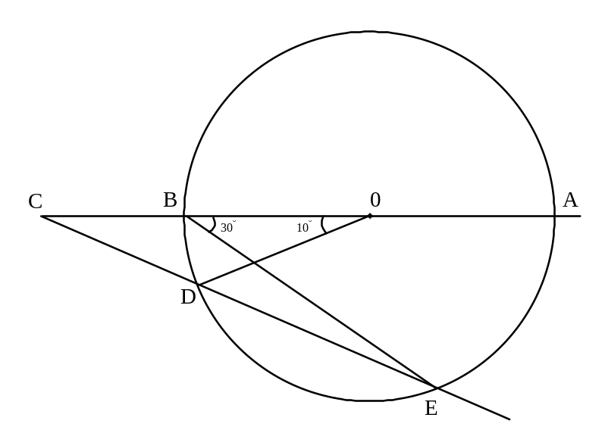

What is the measure of angle ACE?

A) | 25° | C) | 40°
B) | 35° | D) | 70°

The correlation coefficient of the distributions represented by the following scatter plots are approximately -0.81, -0.50, 0.53 and 0.93, but not in that order.
13

Which scatter plot represents a distribution whose correlation coefficient is about 0.53?

A) | 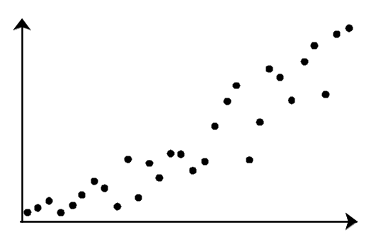 | C) | 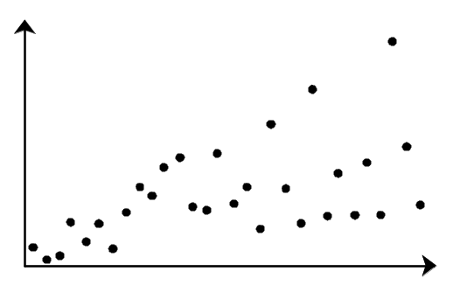
B) | 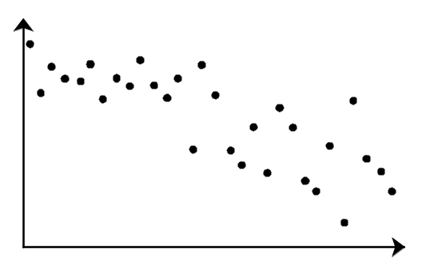 | D) | 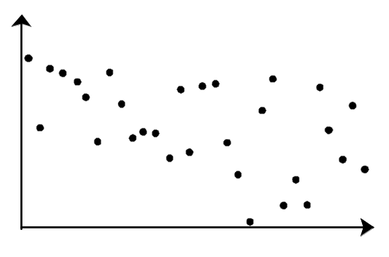

SECTION B | This section of the exam comprises questions 14 and 15.  Write the answer to each question in the appropriate space.

4 | 0
Given vectors u and v where:
14

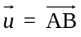 with A(-5, 7) and B(3, -5)
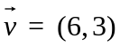

Find 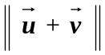. Answer to the nearest tenth.

To the nearest tenth, 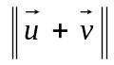 is _________________

4 | 0

A biologist collected 20 samples of a variety of fly and recorded the wing span of the flies in centimetres. The wing spans are recorded in the list below.
15

1.60 | 1.65 | 1.71 | 1.80 | 1.82 | 1.85 | 1.92 | 1.97 | 2.13 | 2.15
2.29 | 2.42 | 2.47 | 2.47 | 2.55 | 2.61 | 2.68 | 2.76 | 2.89 | 2.91

The approximate mean of the lengths is 2.23 cm and the standard deviation is 0.42.

What is the Z-score of a fly with wing span 1.92 cm? Answer to the nearest hundredth.

To the nearest hundredth, the Z-score is ______________
SECTION C | This section of the exam comprises questions 16 to 25.  Show the work used to solve each problem and, where applicable, write your final answer in the space provided.  Marks are allotted on the basis of the following criteria:  - the appropriateness of the method you used to solve the problem,  - the accuracy of your calculations,  - the clarity of the written information.  No marks would be given for a correct final answer if you had not shown any of your work.  Graphs or tables produced using a graphing calculator would have to be presented as part of your work so that the scorer would clearly understand exactly what you have done.

4 | 3 | 2 | 0
Prove that the following expression is an identity:
16

cot P + tan P ≡ cosec P sec P

4 | 3 | 2 | 1 | 0
Find the solution(s) of the equation 2cos²x − 3sin x − 3 = 0 such that
17

x 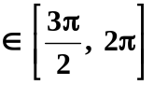. Give your solution(s) in radian measure.

2cos²x − 3sin x − 3 = 0 , x 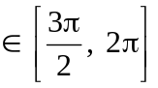

Answer: | The value (s) of x in the domain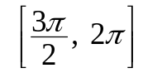 is (are) __________________ radians.

4 | 3 | 2 | 1 | 0

The city council of a town wants to minimize the cost of staffing its recreation centres in the summer months. The council has determined that supervisors will be paid $3500 for the summer and staff workers will be paid $1500 for the summer.
18

The council wants to hire its employees using the following constraints:
• The maximum number of employees for its centres is 30 and the minimum is 18.
• The council also wants to hire at least 6 supervisors but no more than 14 supervisors.
• It wants to hire at least 8 staff workers.
• The number of staff workers must be at most twice the number of supervisors.

How many staff workers and how many supervisors can the town council hire and minimize its costs?

x: number of supervisors  y: number of staff workers |  | 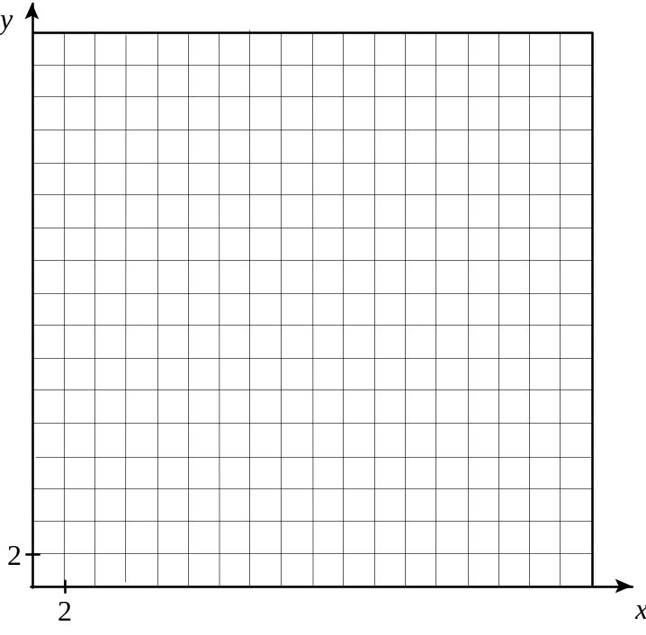
Answer: | The town should hire ______ supervisors and ______ staff workers in order to minimize its costs.

4 | 3 | 2 | 1 | 0

When Jennifer bought a new car in 1995, she paid $17 500. In 1998 the value of her car had fallen to $10 000. She decided that she would sell her car when the value fell below $5000.
19

Assuming the decline in the price of a car is modelled by an exponential function, how old will Jennifer's car be when its value falls below $5000? Round your answer to the nearest month.

Answer: | The value of the car falls below $5000 when it is _____ years ______ months old.

4 | 3 | 2 | 1 | 0

A carpenter places two nails on a rectangular piece of plywood as illustrated in the diagram below. Each nail is placed 20 cm from each of the smaller edges. The smaller edges are 60 cm in length.
20

The carpenter uses these two nails as focal points to draw the largest ellipse possible on the rectangular plane.
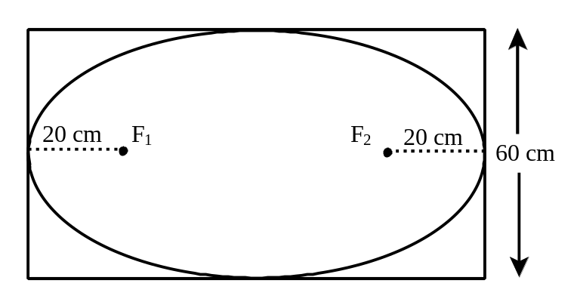

Find the area of the rectangular piece of plywood.

Answer to the nearest cm².

Answer: | To the nearest cm², the area of the plywood is ___________.

4 | 3 | 2 | 1 | 0

As shown in the diagram below, a light is suspended at the focus of a parabolic arch by two cables of equal length. The arch is 8 m across at its base and 3 m high. The cables are attached 1.2 m apart.
21

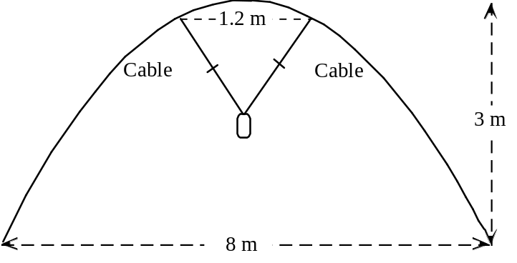

Find the length of each cable.

Answer to the nearest tenth of a metre.

Answer: | Each cable is ___________ m in length.

4 | 3 | 2 | 1 | 0

A new glass has been designed by rotating part of a graph of a square root function about the axis containing the stem of the glass. (Assume the width of the stem to be zero.)
22

As illustrated in the diagram, the diameter of the lip of the bowl is 8 centimetres. The glass stands 13 centimetres in height and the top of the stem of the glass is 5 centimetres high.

A decorative gold ring is to be painted around the bowl 11 centimetres from the bottom of the glass, at a cost of 2 cents per centimetre.

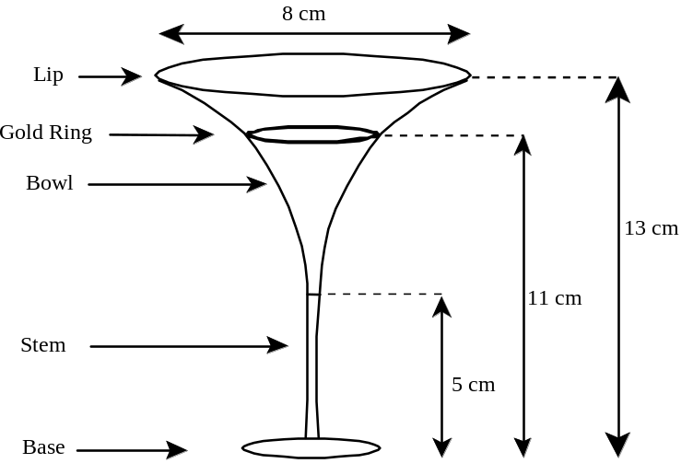

How much will it cost to paint the gold ring around the bowl?

Answer to the nearest cent.

Answer: | To the nearest cent, the cost of the gold ring is ________.

4 | 3 | 2 | 1 | 0
Triangle ABC is inscribed in semicircle with centre O.
23

 is a diameter and 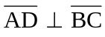.
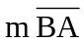 = 17 cm  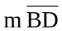 = 15 cm | 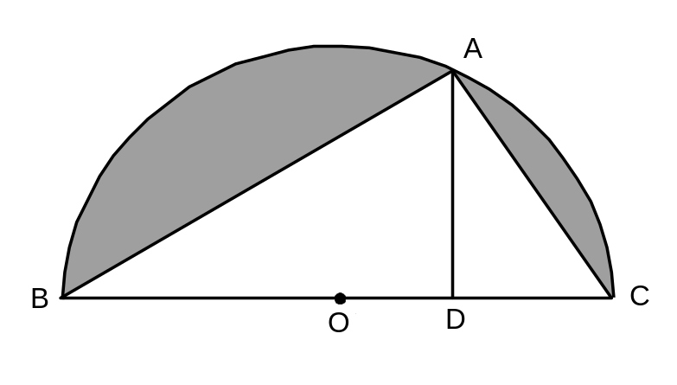
What is the area of the shaded region?

Answer to the nearest cm².

Answer: | To the nearest cm², the area of the shaded region is ________.

4 | 3 | 2 | 1 | 0

Triangle ABD is inscribed in the circle with centre C which is located on segment BD. The arcs AB and AD measure 4 cm and 7 cm respectively.
24

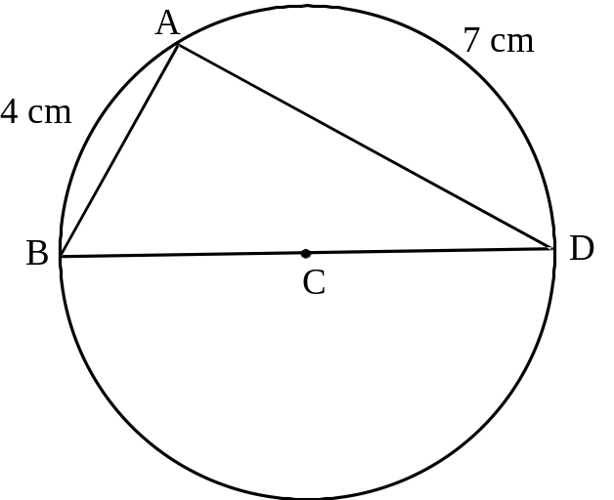

Find the area of triangle ABD.

Answer to the nearest tenth of a cm².

Answer: | The area of triangle ABD is about ____________________ cm².

4 | 3 | 2 | 1 | 0

Susan is a student at Eastern High School. Although she felt her mark in Math 536 was excellent, she was not accepted into the CEGEP course of her choice.
25

Susan's friend Andy is a student at Western High School and obtained the same mark as Susan. Andy informed her that his Z-score at Western High School was 0.62.

The Math 536 end-of-year results for their respective schools are shown in the charts below.

Results in Math 536 at Eastern High School |  | Results in Math 536 at Western High School
56, 59, 60, 61, 62, 63, 65, 65, 66, 67, 68, 70, 70, 71, 71, 72, 73, 74, 75, 76, 79, 80, 81, 83, 85 |  | 63, 65, 67, 69, 71, 71, 72, 74, 75, 75, 77, 77, 79, 79, 80, 81, 82, 84, 84, 85, 87

Believing that the tests and marking in Eastern High School had been more difficult than in Western High School, Susan requested that the CEGEP reconsider her application.

Explain how Susan could justify her request to the CEGEP.

Answer: | Susan's application should be reconsidered because  ______________________________________________________  ______________________________________________________  ______________________________________________________

EXAMINATION #4

SECTION A | This part of the examination consists of questions 1 to 13.  Circle the letter that corresponds to your answer.

The graph on the right represents function f  1  The rule of this function is of the form  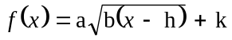. | 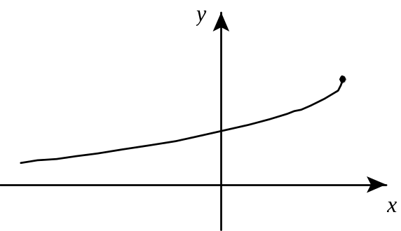

Which of the following statements is FALSE?

A) | a ∈ ]-∞, 0[ | C) | h ∈ ]0, +∞ [
B) | b ∈ ]0, +∞ [ | D) | k ∈ ]0, +∞ [

Which one of the following functions can have more than one zero?
2

A) | Exponential function | C) | Rational function
B) | Logarithmic function | D) | Tangent function

Which of the following functions has an inverse that is itself a function?
3

A) | Cosine function | C) | Square root function
B) | Step function | D) | Absolute value function

Which of the following geometric loci has only one axis of symmetry?
4

A) | A straight line | C) | A hyperbola
B) | An ellipse | D) | A parabola

A group of Secondary V students has decided to sell sweatshirts and caps to raise money for their graduation activities. Their supplier requires them to order at least 1000 items, which must include an order for a minimum of 200 caps. Past experience has shown that they will sell at least twice as many sweatshirts as caps.
5

Which system of inequalities represents these constraints?

x: number of sweatshirts
y: number of caps

A) | x ≥ 0  y ≥ 0  x + y ≥ 1000  y ≤ 200  2x ≥ y | C) | x ≥ 0  y ≥ 0  x + y ≥ 1000  y ≤ 200  x ≥ 2y
B) | x ≥ 0  y ≥ 0  x + y ≥ 1000  y ≥ 200  2x ≥ y | D) | x ≥ 0  y ≥ 0  x + y ≥ 1000  y ≥ 200  x ≥ 2y

The function g is defined by the following rule:
6

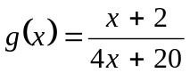

What is the rule of its inverse g⁻¹?

A) | 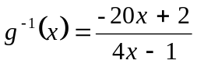 | C) | 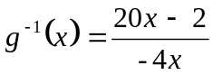
B) | 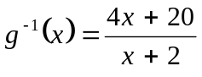 | D) | 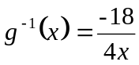

Functions f and g are represented below.
7
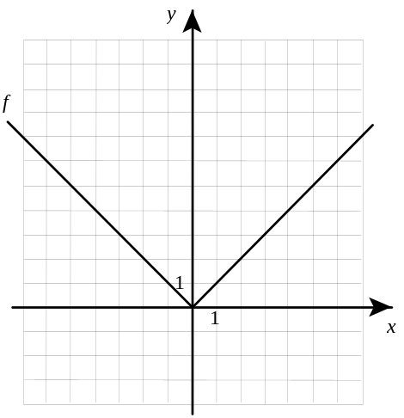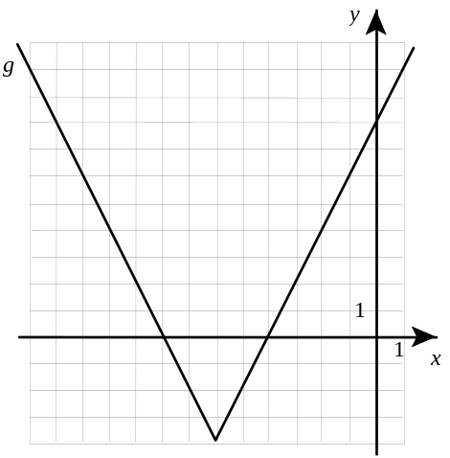
Which of the following is the graph of f g?

A) | 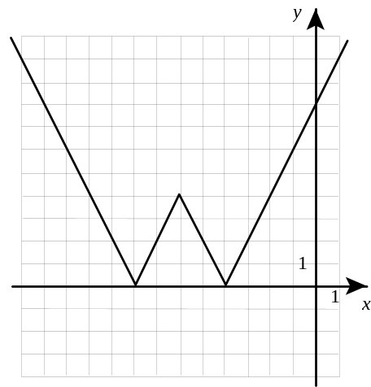 | C) | 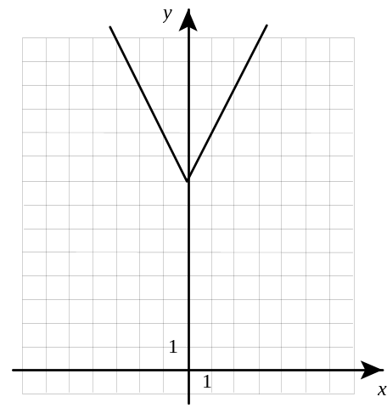
B) | 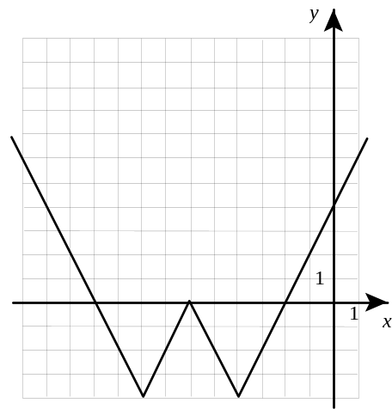 | D) | 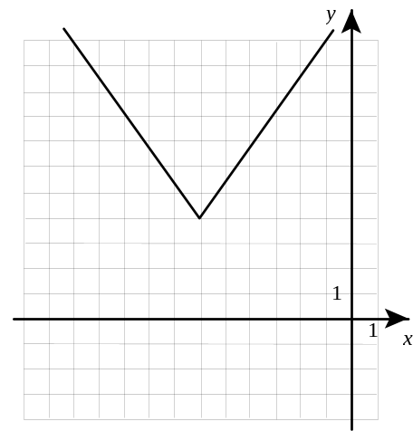

The piston in the motor of a lawn mower moves within a cylinder. The following graph represents the height of the piston, in centimetres, as a function of time in seconds.
8
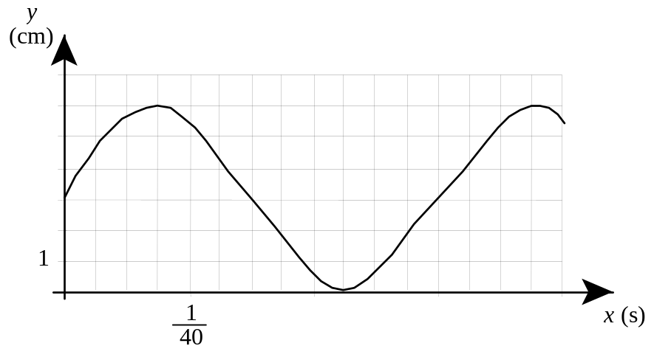
Which expression should be used to determine the height of the piston in the cylinder?

A) | 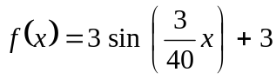 | C) | 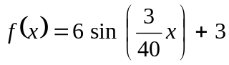
B) | 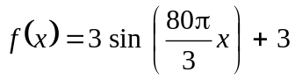 | D) | 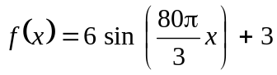

Given the expression 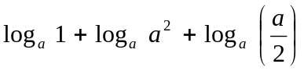, where a is a positive integer not equal to 1.
9

Which of the following is equivalent to the above expression?

A) | 1 | C) | 3 − log_{a} 2
B) | 3.5 | D) | 4 − log_{a} 2

Given the following information:
10

and are nonzero vectors in the plane
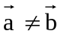
k is a scalar not equal to zero
k ≠ 1

Which of the following statements is true?

A) | 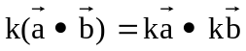
B) | 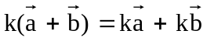
C) | If 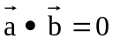 then and are collinear
D) | If = k then and are noncollinear

In the figure on the right, 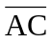 passes through the centre O of the circle. Arc AB measures 60° and is subtended by a chord 2.5 cm long.  11 | 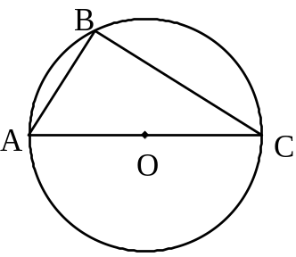

What is the length of chord BC rounded to the nearest tenth of a centimetre?

A) | 1.4 cm | C) | 5.0 cm
B) | 4.3 cm | D) | 5.6 cm

In the diagram below, segments AC and AB are secants of a circle. Chords EB and DC intersect at point F.
12
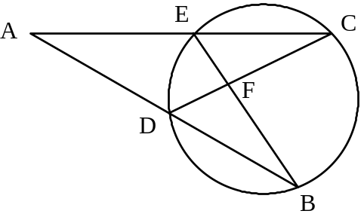
Which of the following statements is FALSE?

A) | 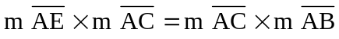 | C) | 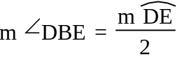
B) | 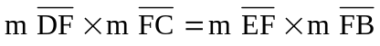 | D) | 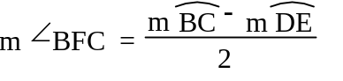

Four distributions are represented below.
13

For which distribution is the correlation between the variables x and y the weakest?

A) | 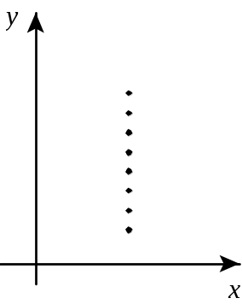 | C) | 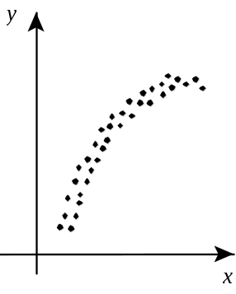
B) | 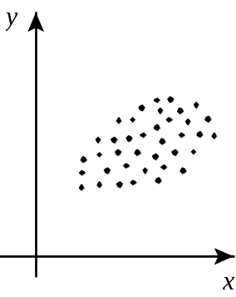 | D) | 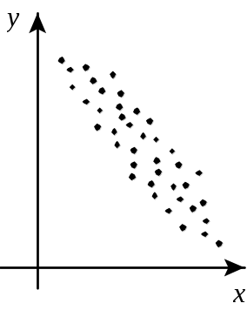

SECTION B | This part of the examination consists of questions 14 to 16.  Write each answer in the space provided.

4 | 0
Which values of x belonging to 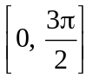 satisfy the equation 4 sin³x − sin x = 0?
14

The values of x belonging to and that satisfy the equation are

_______________________________________________.

4 | 0
Given vectors u and v.
15
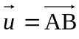 where A(-2, 3) and B(6, 7)
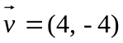

What is the scalar product of vectors u and v?

The scalar product of vectors u and v is __________.

4 | 0

The following table and scatter plot show the relationship between the weight and fuel consumption of 15 cars.
16

Weight  in kg | Fuel  Consumption  in L/100 km | 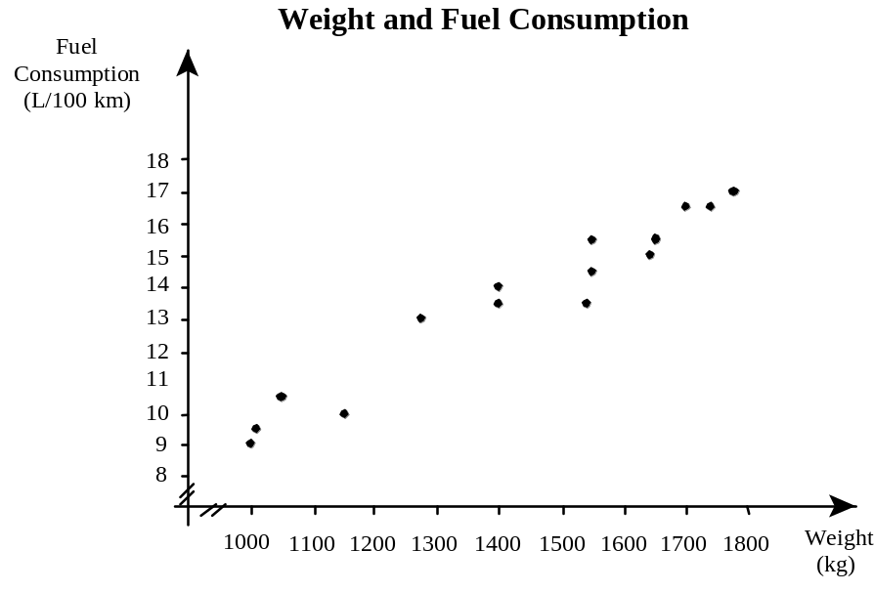
1000 | 9
1010 | 9.5
1050 | 10.5
1150 | 10
1275 | 13
1400 | 13.5
1400 | 14
1540 | 13.5
1550 | 14.5
1550 | 15.5
1640 | 15
1650 | 15.5
1700 | 16.5
1740 | 16.5
1775 | 17

Martha's new car weighs 1200 kg.

According to the above data, how much fuel does Martha's car consume?

According to the above data, Martha's car consumes __________ L/100 km.
SECTION C | This part of the examination consists of questions 17 to 25.  Show the work used to solve each problem and, where applicable, write your final answer.  No marks will be given for the correct final answer if you have not shown your work.

 | 4 | 3 | 2 | 1 | 0

During a fireworks show, two rockets must be launched from two different spots at the same time.
17

The heights, in metres, of the two rockets as a function of time t, in seconds, are represented by the following equations:
h₁(t) = -12.5(t − 4)² + 200
h₂(t) = 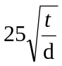 + 50

Both rockets must explode 6 seconds after they have been launched. They must also explode at the same height.

What is the value of parameter d?

Answer The value of parameter d is _______________.

 | 4 | 3 | 2 | 1 | 0

One very hot summer day, the outside temperature is described by the following rule:
18

T(x) = -3 | x − 6 | + 36

where x represents the number of hours that have elapsed since sunrise
T(x) represents the temperature in ºC

To make the temperature inside a shopping centre more comfortable, an air conditioning system starts up when the outside temperature reaches 21 °C and stops when the outside temperature drops to 20 °C.

How long was the air conditioning system in operation on that day?

Show all your work
Answer On that day, the air conditioning system was in operation for _______________.
(Include the unit of measurement)

 | 4 | 3 | 2 | 1 | 0

The value of a certain amount of capital C_{o} invested at a given rate of interest i for t years will be as follows:
19

C(t) = C_{o}(1 + i)^{t}

Emily invested the $2000 she received for winning a design contest. This money will earn the same rate of interest throughout the term of the investment.

The following table of values shows the value of Emily's investment as a function of time in years.

Term of the Investment  (years) | Value of the Investment  ($)
1 | 2200
3 | 2662

How much will Emily's investment be worth after 10 years?

Answer Emily's investment will be worth $_______________ after 10 years.

 | 4 | 3 | 2 | 1 | 0

Highways in the shape of hyperbolas run alongside asymptotes and merge with a circular intersection.
20

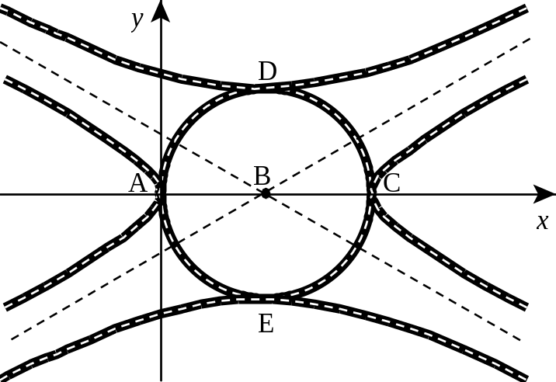

In the diagram above:

- points D, B and E are collinear,
- the circle is 12 units in diameter,
- the foci of the hyperbola with vertices D and E are 20 units apart,
- vertex A is located at the origin of the Cartesian coordinate system,
- point B is the centre of the circle.

What is the equation of the hyperbola with vertices D and E?

Answer The equation of the hyperbola with vertices D and E is _______________.

 | 4 | 3 | 2 | 1 | 0

A car race takes place on an elliptical track. The foci of the ellipse are 500 m apart.
21

Luke and Nathalie, each located at one of the foci of the ellipse, were looking at the same car at a certain point during the race. At that moment, each person's line of vision made an angle of 45° with the major axis.

Rounded to the nearest tenth, what is the shortest distance between Luke and the track?

Answer Rounded to the nearest tenth, the shortest distance between Luke and track is ____________ metres.

 | 4 | 3 | 2 | 1 | 0

A campground offers two types of campsites: those for tents and those for trailers.
22

Tent users consume an average of 10 litres of water a day, and people using trailers consume an average of 30 litres a day. The town where the campground is located has a by-law stipulating that the owner can have no more than 3300 litres of water a day. The campground has 150 campsites.

This situation is represented by the following system of inequalities:
x ≥ 0
y ≥ 0
10x + 30y ≤ 3300
x + y ≤ 150

where x represents the number of rentals of campsites for tents,
y represents the number of rentals of campsites for trailers.

On a daily basis, it costs twice as much to rent a campsite for a trailer as it does to rent a campsite for a tent. The maximum daily profit is $4800.

How much does it cost per day to rent each type of campsite?

Show all your work
Answer It costs $_________ per day to rent a campsite for a tent.

It costs $_________ per day to rent a campsite for a trailer.

 | 4 | 3 | 2 | 1 | 0

In quadrilateral ABCD illustrated below, points M, N, O and P are the midpoints of segments AB, BC, CD and DA respectively.
23

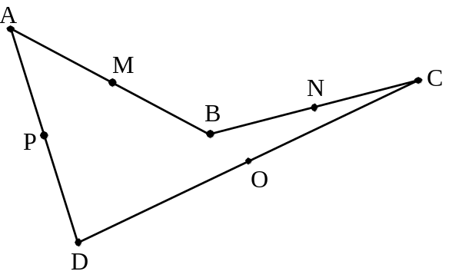

Using the above figure, prove the following proposition: "The midpoints of the sides of any quadrilateral form the vertices of a parallelogram."

 | 4 | 3 | 2 | 1 | 0

Altitude AB is drawn in triangle ACD as shown in the diagram on the right.  24  A cone is generated by rotating triangle ACD 360° about axis AB. | 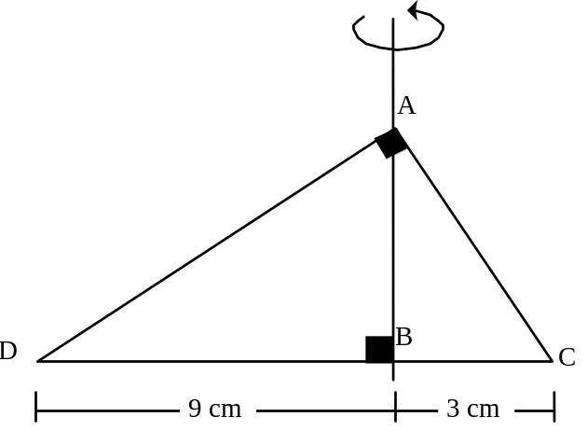
What is the volume of this cone to the nearest cm³?

Note Volume of a cone = 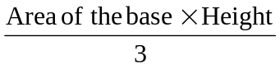

Answer The volume of this cone to the nearest cm³ is _______________ cm³.

 | 4 | 3 | 2 | 1 | 0

The following table gives information on the results pertaining to four students from four different schools.
25

 | Group Mean | Standard Deviation for the Group | Student's Mark
Sanjay | 81 | 4 | x
Marie | 72 | 8 | 88
Kim Thy | y | 6 | 89
Simon | 78 | z | 84

These 4 students applied to the same CEGEP program, but only one more student can be admitted to this program.

After calculating each student's Z-score, the CEGEP admitted Marie because she had the best Z-score.

In the table above, there are several possible values for each of the variables x, y and z.

Give one possible value for each variable.

Explain your answers.
x: Sanjay's Mark | x =
y: Mean for Kim Thy's Group | y =
z: Standard Deviation for Simon's Group | z =

